**ENVIRONMENTAL IMPACT CALCULATOR**

**Flow Chart Diagram**

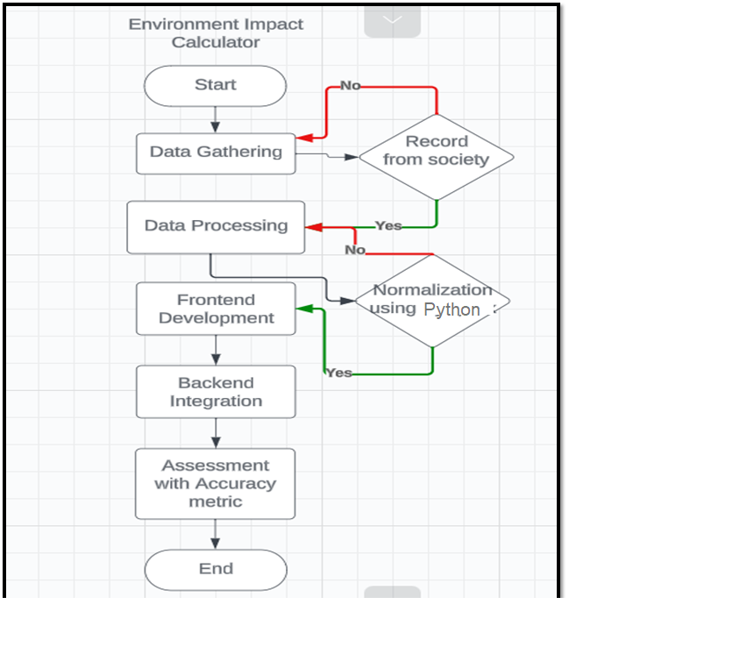

**ER Diagram**

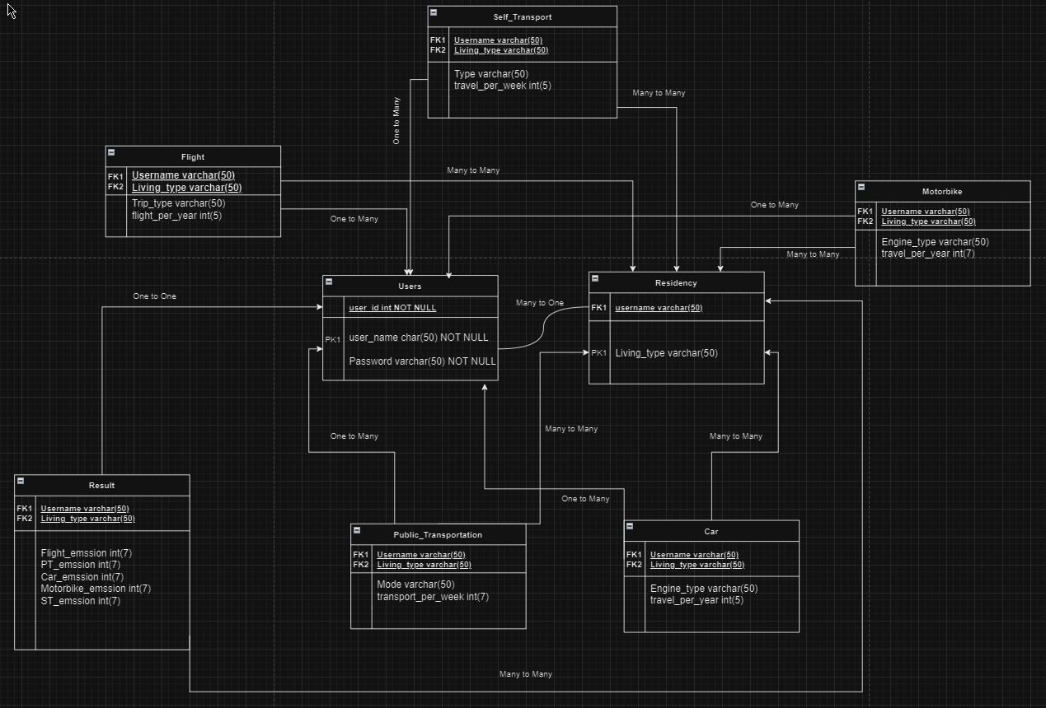

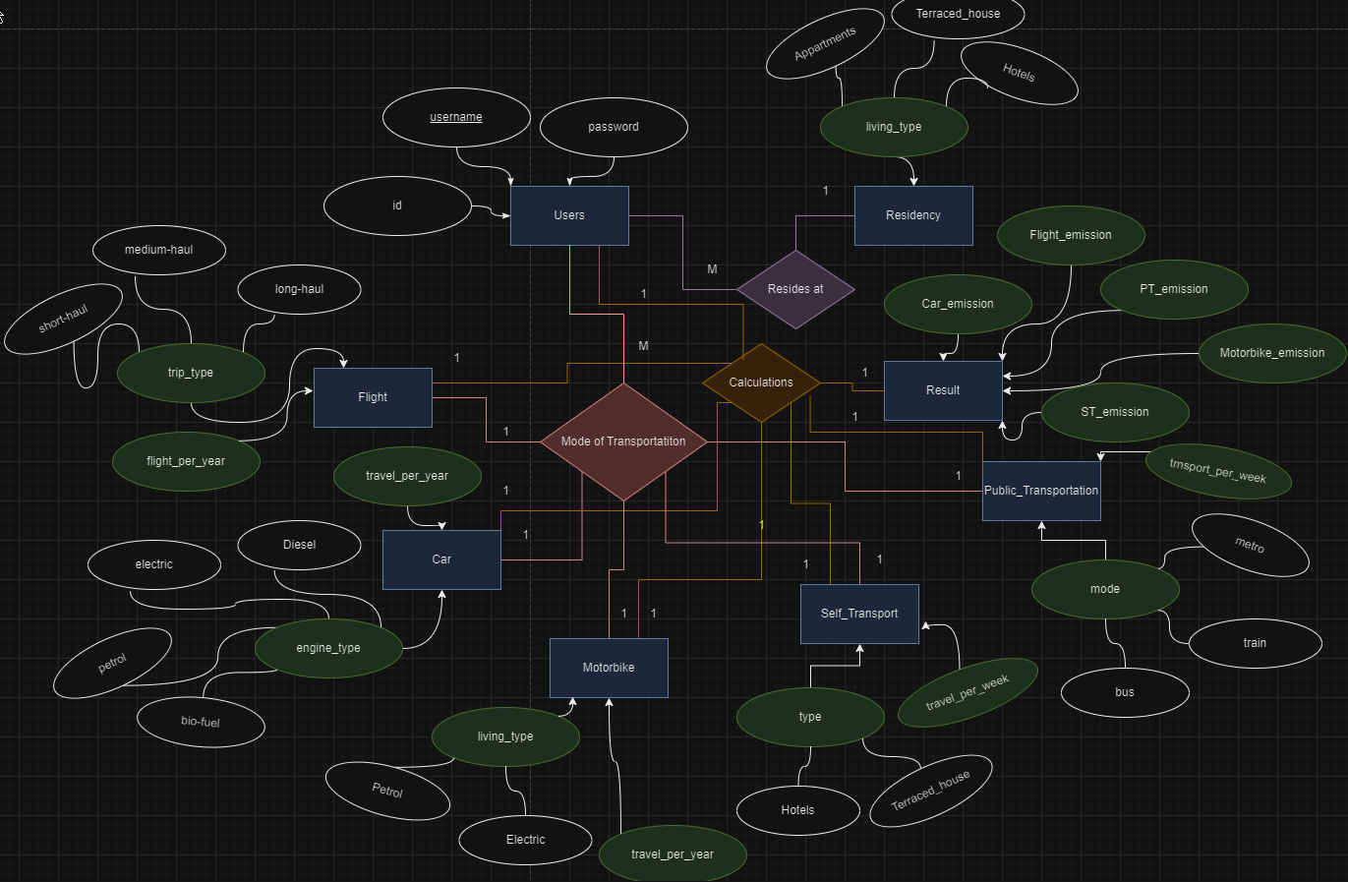

**Web App Flow Diagram**

